Mid-April 2020 Social Media Content Calendar: Heavy Push/Get out the Count
To add pictures to social media, right-click on the image and select “save picture as” to save image on your computer. Doing this restores correct sizing when uploading to social media.
Image | Facebook/Instagram | Twitter
Week of April ____________  (Misinformation)  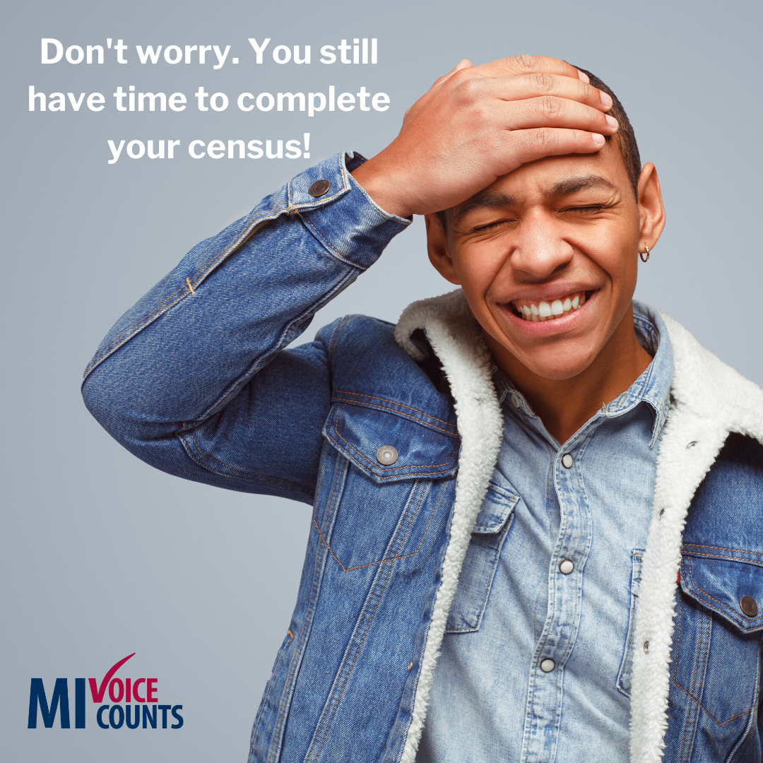 | The 2020 census is still ongoing. April 1 was not a deadline. Fill out your census online > https://2020census.gov/, by mail or phone > 844-330-2020.  .  #MIVoiceCounts #BeCountedMI2020 #2020Census #census2020 #everyonecounts #yourvoicematters | The 2020 census is still ongoing. April 1 was not a deadline. Fill out your census online > https://2020census.gov/, by mail or phone > 844-330-2020.  .  #MIVoiceCounts #BeCountedMI2020 #2020Census #census2020 #everyonecounts #yourvoicematters
Week of April ______________  (Community Resources)  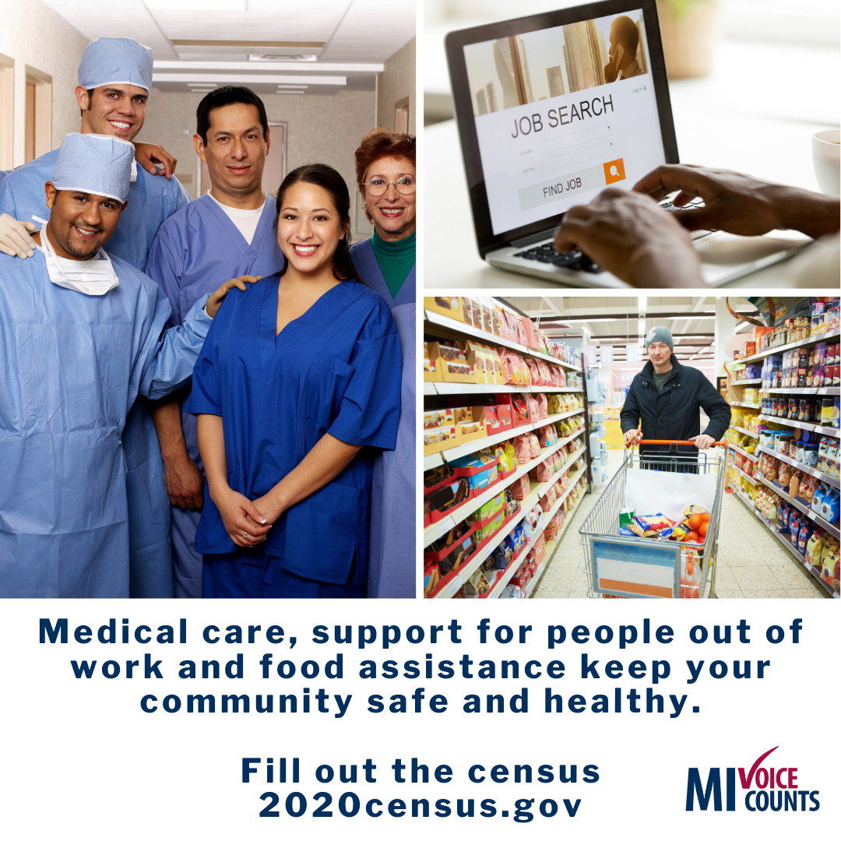 | The 2020 census is happening right now. Keep your community safe and healthy by bringing resources like medical care, support for people out of work, and food assistance.  Fill out your census online > https://2020census.gov/, by mail or phone > 844-330-2020.  #2020Census #census2020 #foodassistance #communityresources | The 2020 census is happening right now. Keep your community safe and healthy by bringing resources like medical care, support for people out of work, and food assistance.  Fill out your census online > https://2020census.gov/, by mail or phone > 844-330-2020.  #2020Census #census2020 #foodassistance #communityresources
Week of April ______________  (Disinformation)  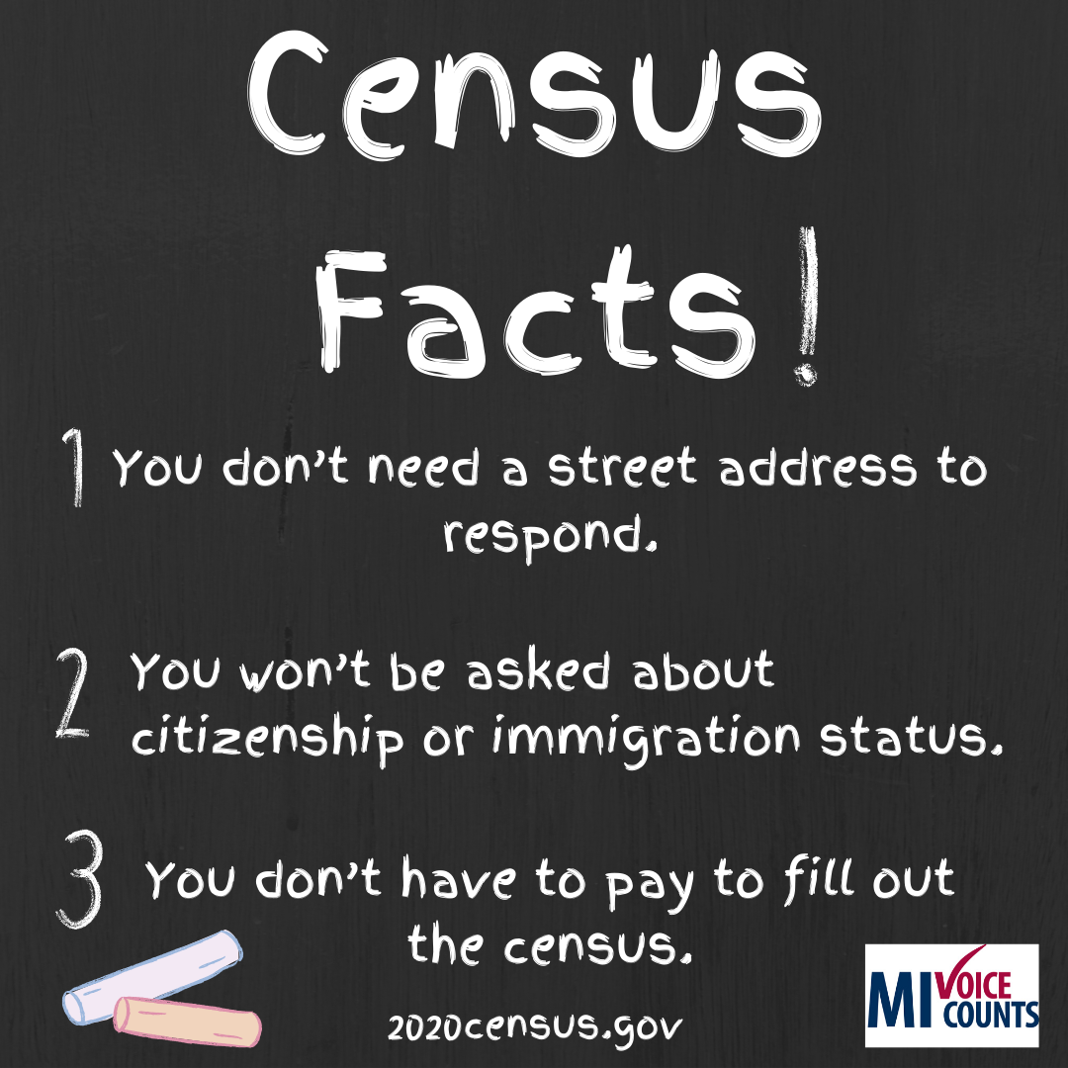 | Don’t let rumors and #misinformation keep you from filling out the census. Here are the facts:  - You don’t have to pay to fill out the #census.  - You don’t need a street address to respond.  - You can fill it out if you forget your unique ID.  - You won’t be asked about citizenship or immigration status.  Got more questions? Visit https://2020census.gov/  #2020Census #census2020 #privacy #confidential | Don’t let rumors and #misinformation keep you from filling out the #2020census. Here are the facts:  - You don’t have to pay to fill out the #census.  - You don’t need a street address to respond.  - You can fill it out if you forget your unique ID.  Got questions? Visit https://2020census.gov/
Week of April ____________  (Count Everyone)  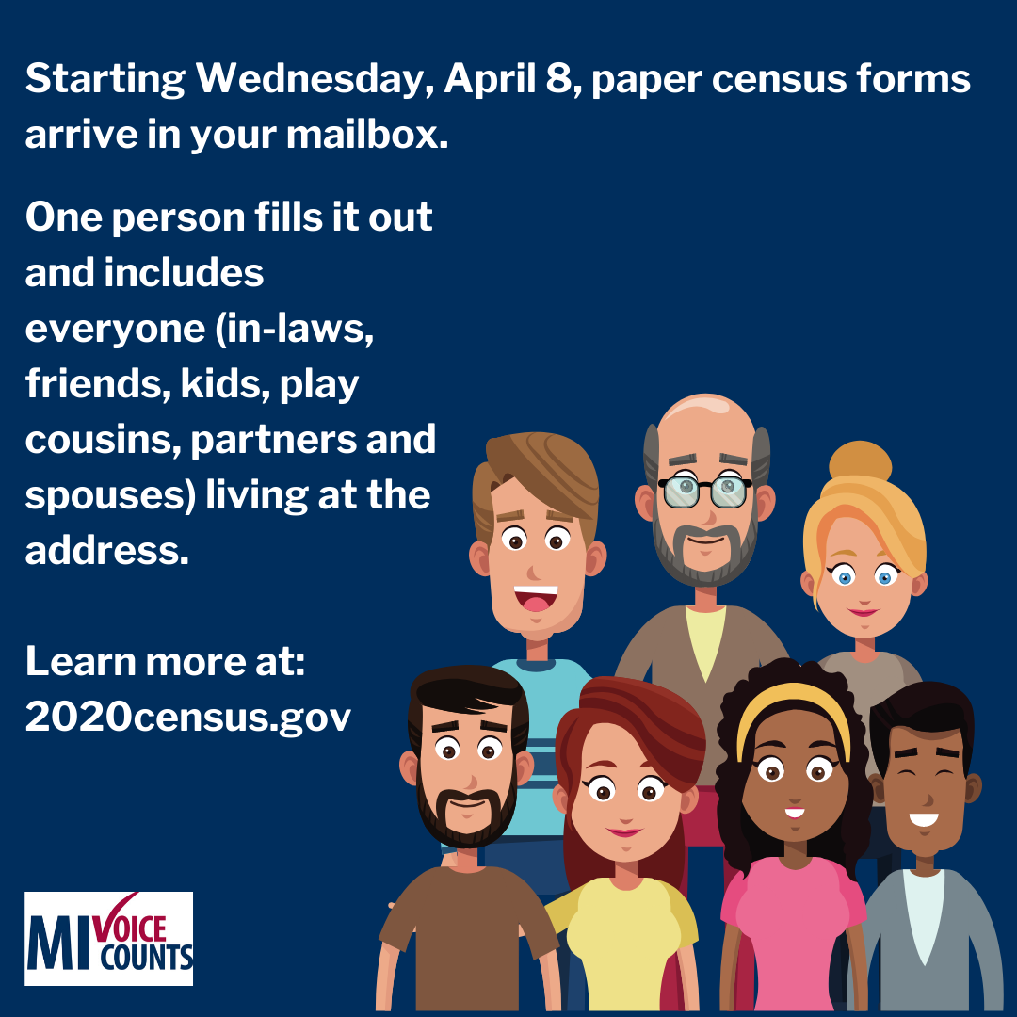 | Starting Wednesday, April 8, paper census forms will hit your mailbox.  .  Census forms are filled out by household. One person fills it out and includes everyone living at the address. Everyone living there (in-laws, friends, play cousins, partners, and spouses) needs to be counted, kids too!  Learn more here> https://2020census.gov/  .  #2020Census #census2020 #relationshipstatus | Starting Wednesday, April 8, paper #census forms will hit your mailbox.  .  One person fills it out and includes everyone (in-laws, friends, kids, play cousins, partners, and spouses) living at the address.  Learn more here> https://2020census.gov/  .  #2020Census #census2020 #relationshipstatus
Week of April ______________  (Stay Home. Stay Safe. Fill out the census.)  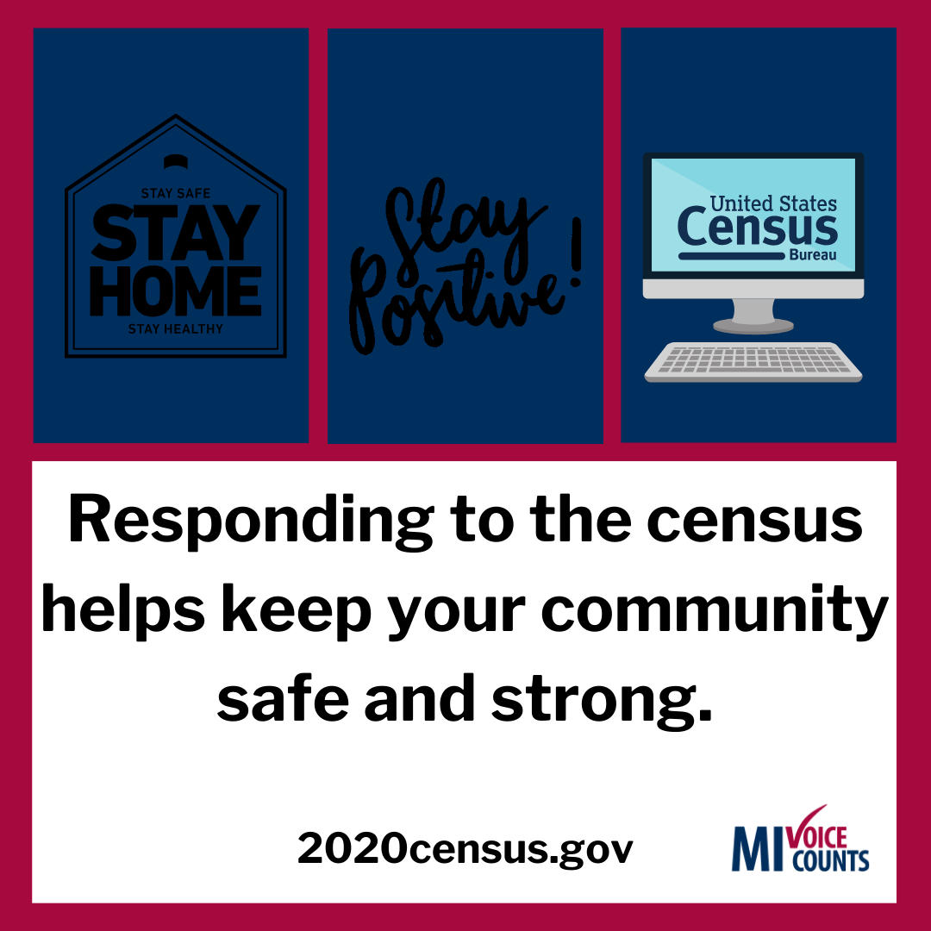 | People across America are keeping their families and communities safe and healthy by staying home or serving the public by providing essential services. Responding to the #census is another way to help keep your community safe and strong.  https://2020census.gov/  #2020Census #census2020 #essentialservices | People across America are keeping their families and communities safe and healthy by staying home or serving the public by providing essential services. Responding to the #census is another way to help keep your community safe and strong.  https://2020census.gov/  #2020Census #census2020 #essentialservices
Week of March _____________  (Medical Programs) Everyone gets sick! | Everyone gets sick.  These last few weeks have shown that having access to medical care can be a matter of life or death.  .  Fill out the census online> https://2020census.gov/, by mail or phone> 844-330-2020, so you and your entire family can get proper medical care when you need it.  #2020Census #census2020 #medicalcare #medicalemergency | Everyone gets sick.  These last few weeks have shown that having access to medical care can be a matter of life or death.  .  Fill out the census online> https://2020census.gov/, by mail or phone> 844-330-2020, so you and your entire family can get proper medical care when you need it.  #2020Census #census2020 #medicalcare #medicalemergency

