May 2020 Social Media Content Calendar: Heavy Push/Get out the CountZ
To add pictures to social media, right-click on the image and select “save picture as” to save image on your computer. Doing this restores correct sizing when uploading to social media.
Image | Facebook/Instagram | Twitter
Week of May ____________  (Census Video Challenge) | Quarantine got your creative juices flowing? Could you use an extra $30,000? If you can produce impactful and innovative video content for the #2020Census, you could win up to 30K!  Learn more here>  https://go.usa.gov/xvkSy  #census2020 #videocontent #contentcreator #pandemicprojects | Quarantine got your creative juices flowing? Could you use an extra $30,000? If you can produce impactful and innovative video content for the #2020Census, you could win up to 30K!  Learn more here>  https://go.usa.gov/xvkSy  #census2020 #videocontent #contentcreator #pandemicprojects
Week of May ______________  (Mother’s Day)  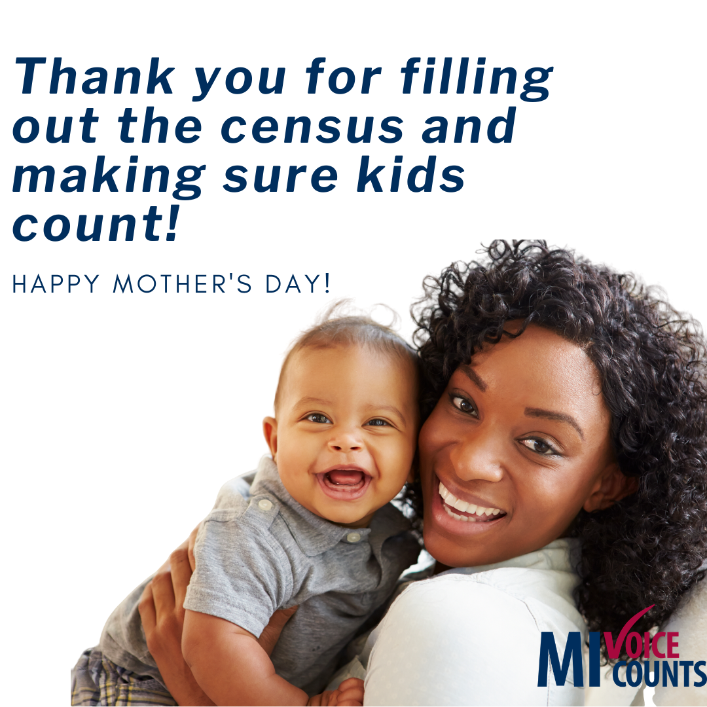 | This Mother’s Day will see an increase in homemade cards, meals cooked at home, and gifts ordered online. It’s a small way to say, “thank you” for all the ways Moms love their children.  Thank you to all the moms for filling out the census and making sure kids count!  https://2020census.gov/  #2020Census #census2020 #momsarethebest #celebratemom | Happy Mother’s Day!!!  Thank you to all the moms for filling out the census and making sure kids count!  https://2020census.gov/  #2020Census #census2020 #momsarethebest #celebratemom
Week of May ______________  (Community Resources)  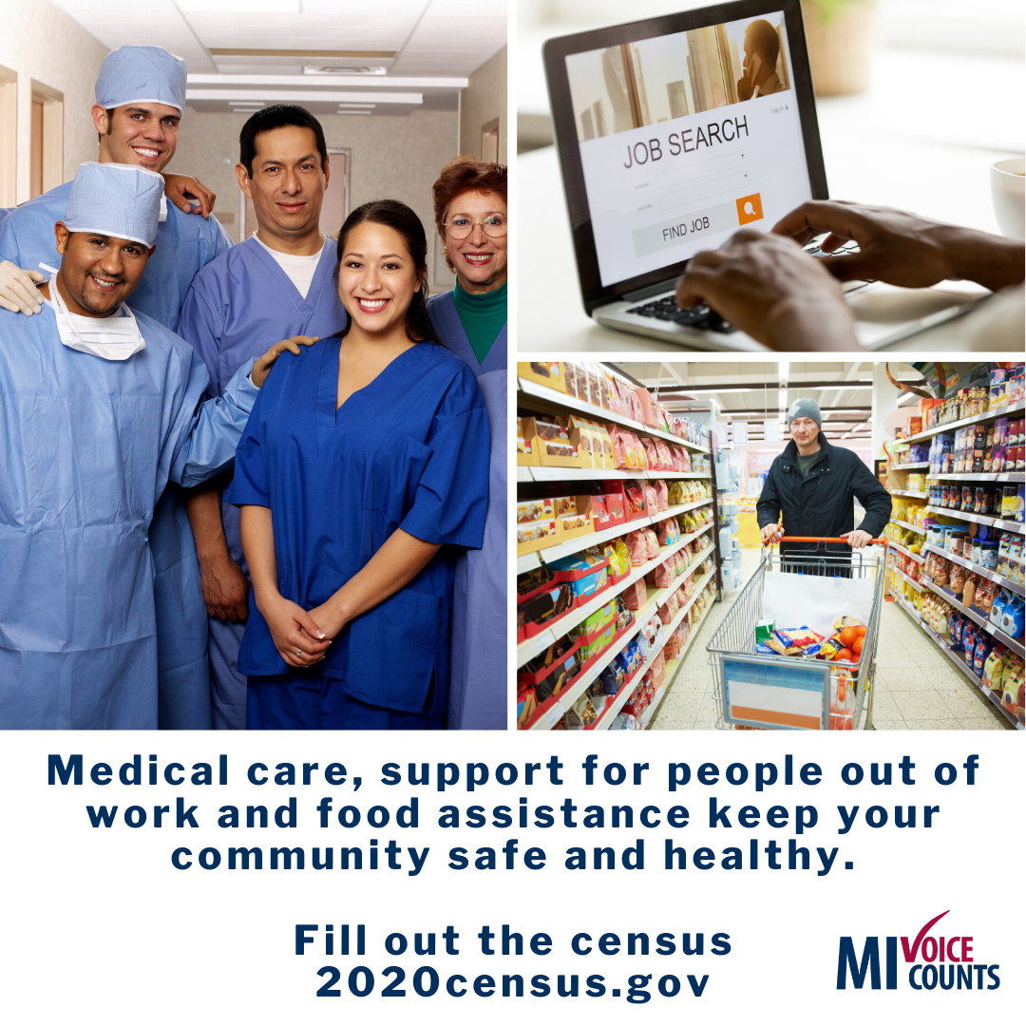 | The 2020 census is happening right now. Keep your community safe and healthy by bringing resources like medical care, support for people out of work, and food assistance.  Fill out your census online > https://2020census.gov/, by mail or phone > 844-330-2020.  #2020Census #census2020 #foodassistance #communityresources | The 2020 census is happening right now. Keep your community safe and healthy by bringing resources like medical care, support for people out of work, and food assistance.  Fill out your census online > https://2020census.gov/, by mail or phone > 844-330-2020.  #2020Census #census2020 #foodassistance #communityresources
Week of May ______________  (Census Facts)  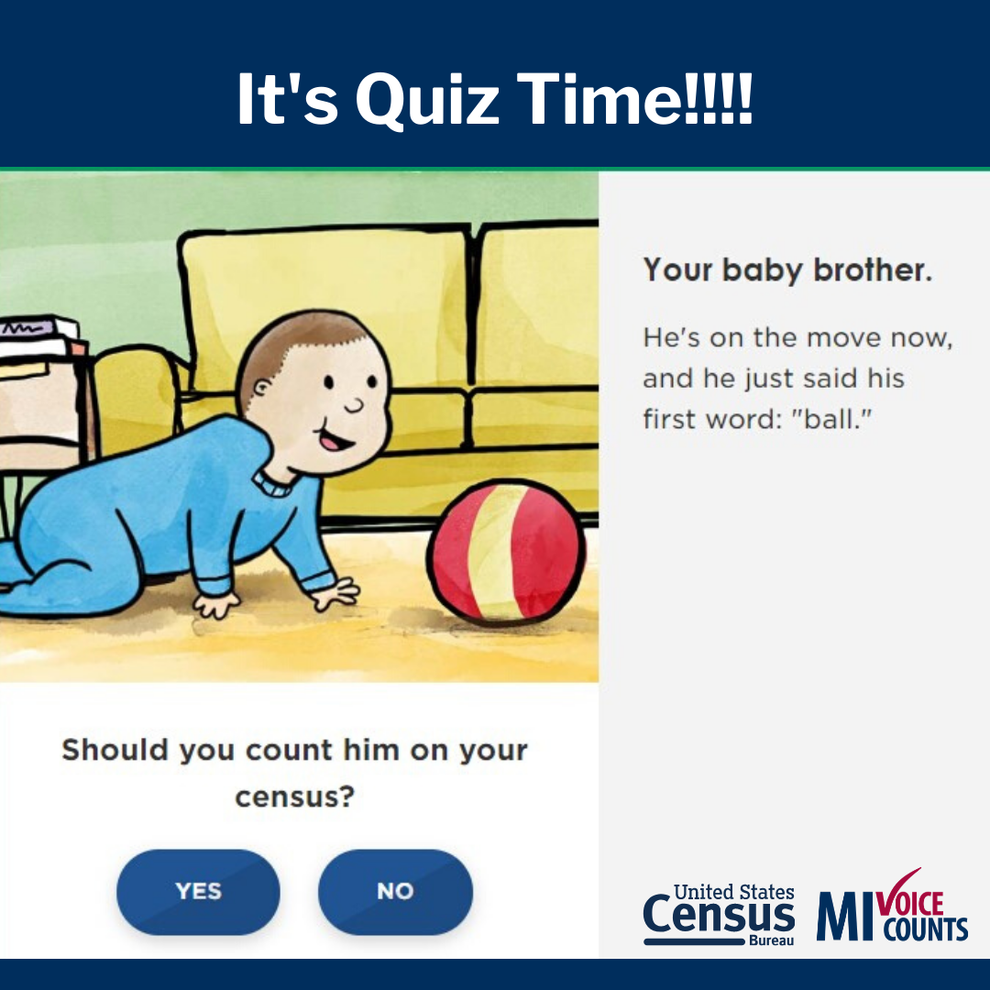 | Current events make for great teaching moments. Help kids learn about the census and who counts in their home with this fun interactive quiz: https://go.usa.gov/xvTBS  #2020Census #census2020 #kidscount #quarantineschool #pandemicparenting | Current events make for great teaching moments. Help kids learn about the census and who counts in their home with this fun interactive quiz: https://go.usa.gov/xvTBS  #2020Census #census2020 #kidscount #quarantineschool #pandemicparenting
Week of May ____________  (MI Response Rate)  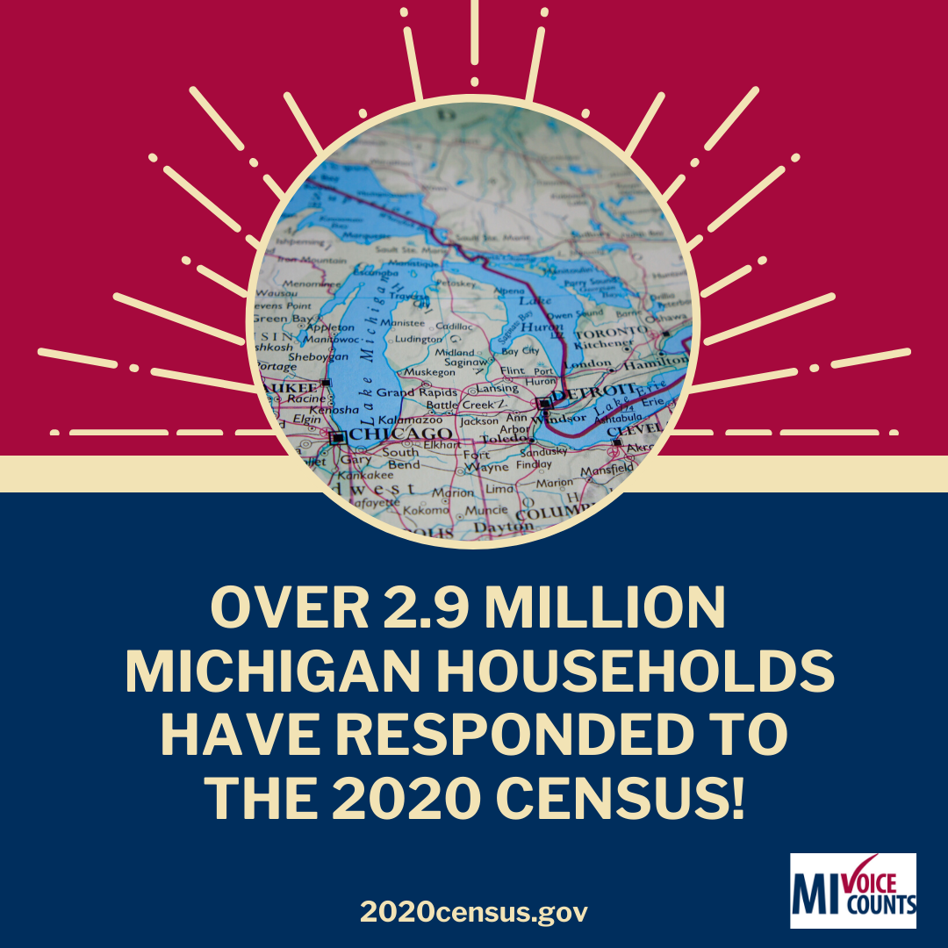 | Over 2.9 million Michigan residents have responded to the #2020census. Want to see the response rate for your community? Visit: 2020census.gov/en/response-rates.  .  #MIVoiceCounts #BeCountedMI2020 #census2020 #everyonecounts #yourvoicematters | Over 2.9 million Michigan residents have responded to the #2020census. Want to see the response rate for your community? Visit: 2020census.gov/en/response-rates.  .  #MIVoiceCounts #BeCountedMI2020 #census2020 #everyonecounts #yourvoicematters
Week of May _____________  (Medical Programs) Everyone gets sick! | Everyone gets sick.  These last few weeks have shown that having access to medical care can be a matter of life or death.  .  Fill out the census online> https://2020census.gov/, by mail or phone> 844-330-2020, so you and your entire family can get proper medical care when you need it.  #2020Census #census2020 #medicalcare #medicalemergency | Everyone gets sick.  These last few weeks have shown that having access to medical care can be a matter of life or death.  .  Fill out the census online> https://2020census.gov/, by mail or phone> 844-330-2020, so you and your entire family can get proper medical care when you need it.  #2020Census #census2020 #medicalcare #medicalemergency

