March 2020 Social Media Content Calendar: Heavy Push/Get out the Count
To add pictures to social media, right click on the image and select “save picture as” to save image on your computer. Doing this restores correct sizing when uploading to social media.
Image |  |  | Facebook/Instagram | Twitter
Week of March ____________  (Disinformation)  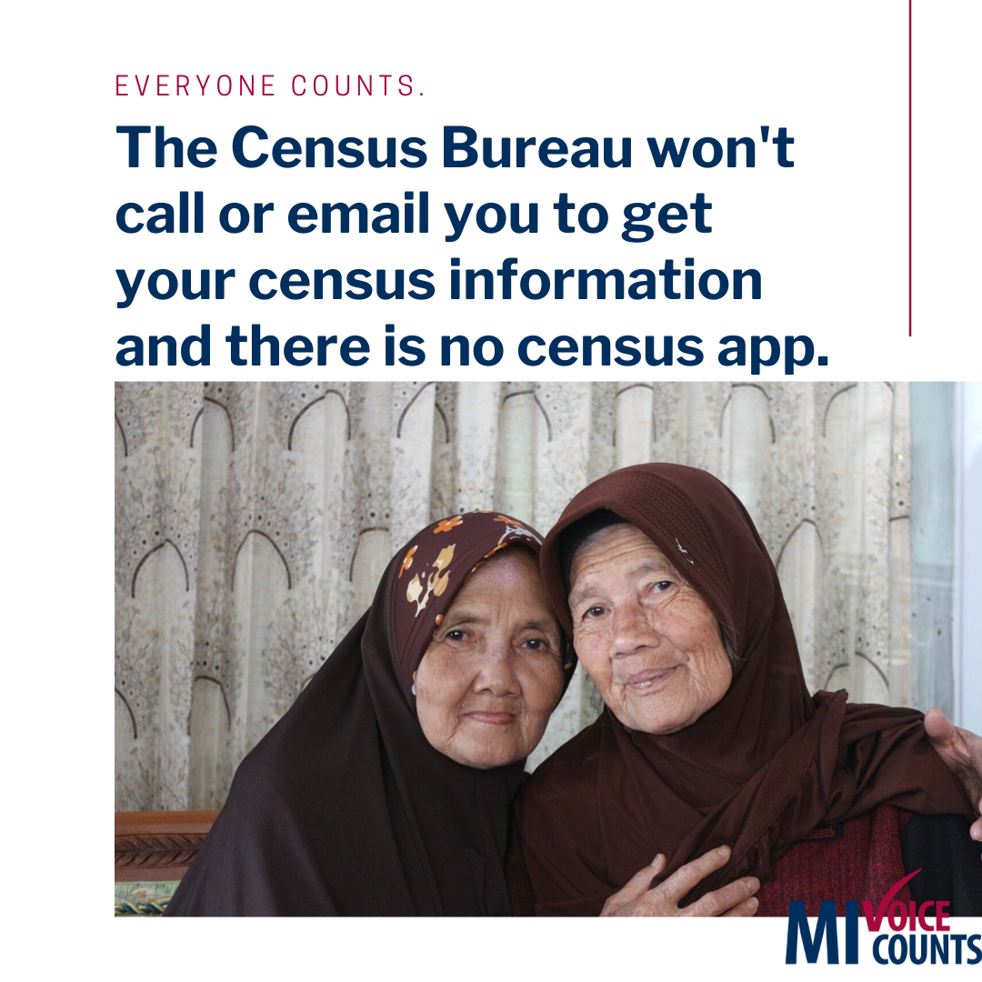 |  |  | Invitations to fill out the census go out this month and it’s easier than ever to respond. You can respond online or by phone in English or in 12 additional languages. A video in American Sign Language (ASL) is available to guide you through responding online.  .  Census forms are filled out by household. Everyone living at the address matters and everyone needs to be counted- including children.  www.MIVoiceCounts.org  #MIVoiceCounts #BeCountedMI2020 #2020Census #census2020 #everyonecounts #celebratediversity | Invites to fill out the census go out this month and it’s easier than ever to respond. Online or by phone in English or 12 additional languages. A video in American Sign Language (ASL) can guide you through responding online.  #MIVoiceCounts #BeCountedMI2020 #2020Census #census2020 #everyonecounts
Week of March ______________  (Confidentiality)  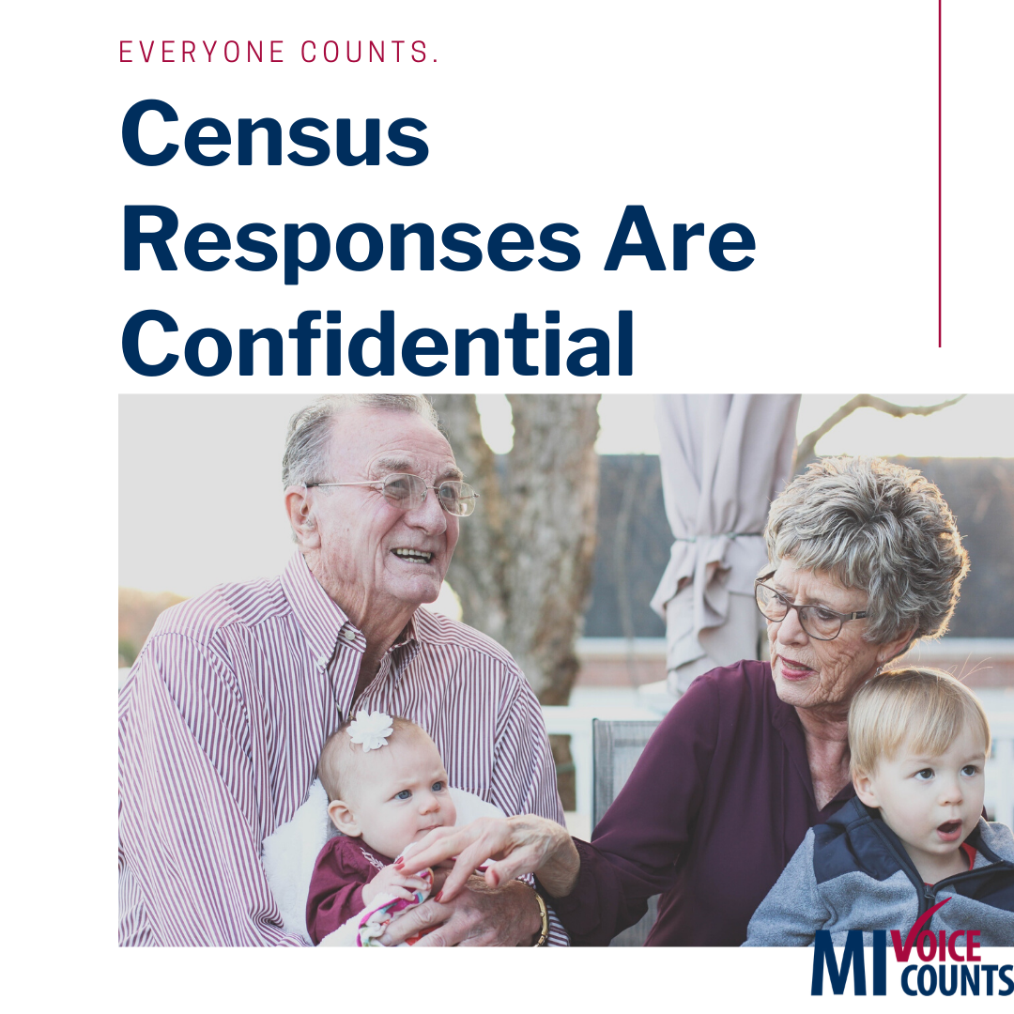 |  |  | The Census Bureau is committed to keeping your information confidential, private and secure.  It’s the law that your census information cannot and will not be shared with ANY agency. Check out the nine census questions here: www.MIVoiceCounts.org  #MIVoiceCounts #BeCountedMI2020 #2020Census #census2020 #privacy #confidential | The Census Bureau is committed to keeping your information confidential, private and secure.  It’s the law that your census information cannot be shared with ANY agency. Check out the nine census questions here: www.MIVoiceCounts.org  #MIVoiceCounts #BeCountedMI2020 #2020Census #census2020 #privacy #confidential
Week of March ______________  (Disinformation)  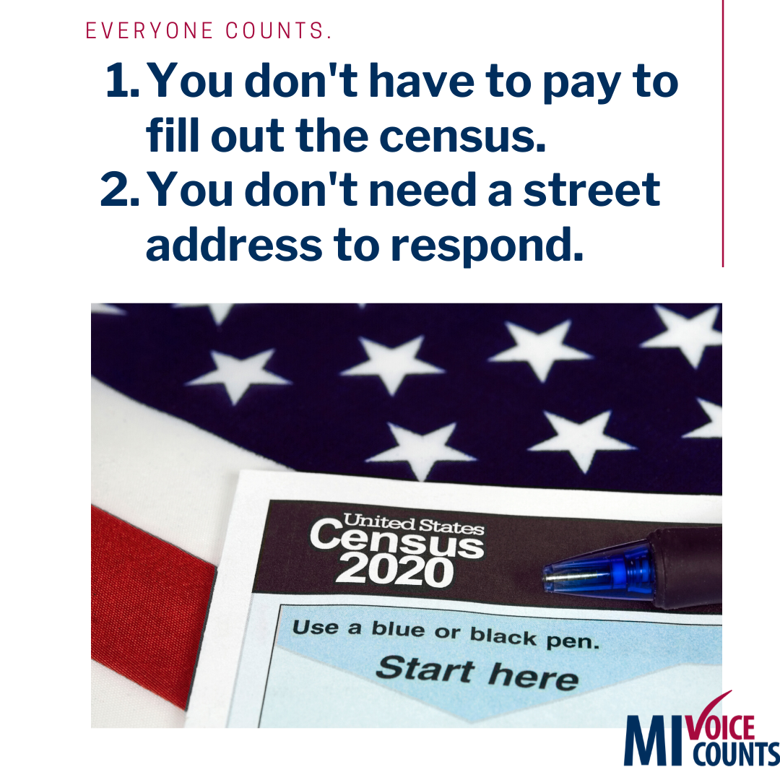 |  |  | Don’t let rumors and #misinformation keep you from filling out the census. Here are the facts:  - You don’t have to pay to fill out the #census.  - You don’t need a street address to respond.  - You can fill it out if you forget your unique ID.  - The Census Bureau won’t call or email you to get your census information.  - You won’t be asked about citizenship or immigration status.  Got more questions? Visit MIVoiceCounts.org.  #MIVoiceCounts #BeCountedMI2020 #2020Census #census2020 #privacy #confidential | Don’t let rumors and #misinformation keep you from filling out the #2020census. Here are the facts:  - You don’t have to pay to fill out the #census.  - You don’t need a street address to respond.  - You can fill it out if you forget your unique ID.  Got questions? Visit MIVoiceCounts.org.  #MIVoiceCounts #BeCountedMI2020
Week of March ____________  (Confidentiality/ Disinformation)  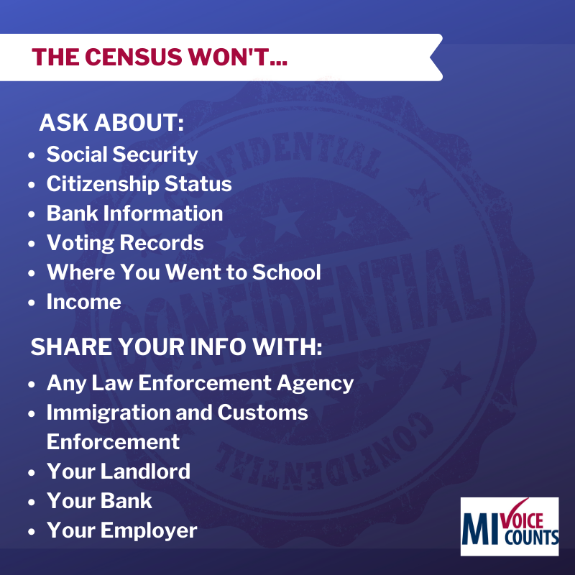 |  |  | Invites to fill out the census go out this month!  The #census asks for less personal information than most social media profiles. Items like name, gender, age, birthday, race/ethnicity and phone number are asked. By law, your information is secure and confidential.  .  Census forms are filled out by household. Everyone living at the address matters and everyone needs to be counted- including children.  .  Your voice counts Spring 2020.  Checkout the 9 census questions here: www.MIVoiceCounts.org  #MIVoiceCounts #BeCountedMI2020 #2020Census #census2020 | Invites to fill out the census go out this month!  The #census asks for less personal information than most social media profiles. Items like name, gender, age, birthday, race/ethnicity and phone number are asked. Your information is secure and confidential.  #MIVoiceCounts #BeCountedMI2020 #2020Census #census2020
Week of March ____________  (Count Everyone)  Census forms are filled out by household.  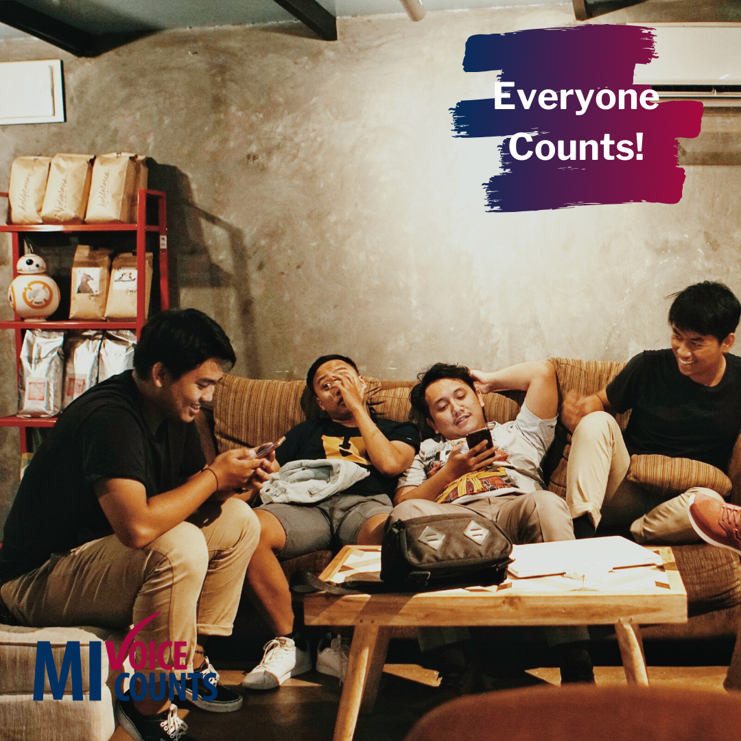 |  |  | Everyone in this picture lives at the same address and is part of the same household. They are not related to each other but are counted together for the #census.  .  If we make sure we’re all counted, then we’ll get the funding we need and get our fair chance at helping shape the next 10 years. Even if you can’t vote, the census is a way to participate in our democracy and ensure you’re not erased. We only have one chance to get this right.  www.MIVoiceCounts.org  #MIVoiceCounts #BeCountedMI2020 #2020Census #census2020 #roommates | Everyone in this picture lives at the same address. They are not related, but are counted together for the #census.  Census forms are filled out by household. Everyone living at the address needs to be counted- including children.  www.MIVoiceCounts.org  #MIVoiceCounts #BeCountedMI2020 #2020Census #census2020 #roommates
Week of March ______________  (Disinformation/ Everyone Counts)  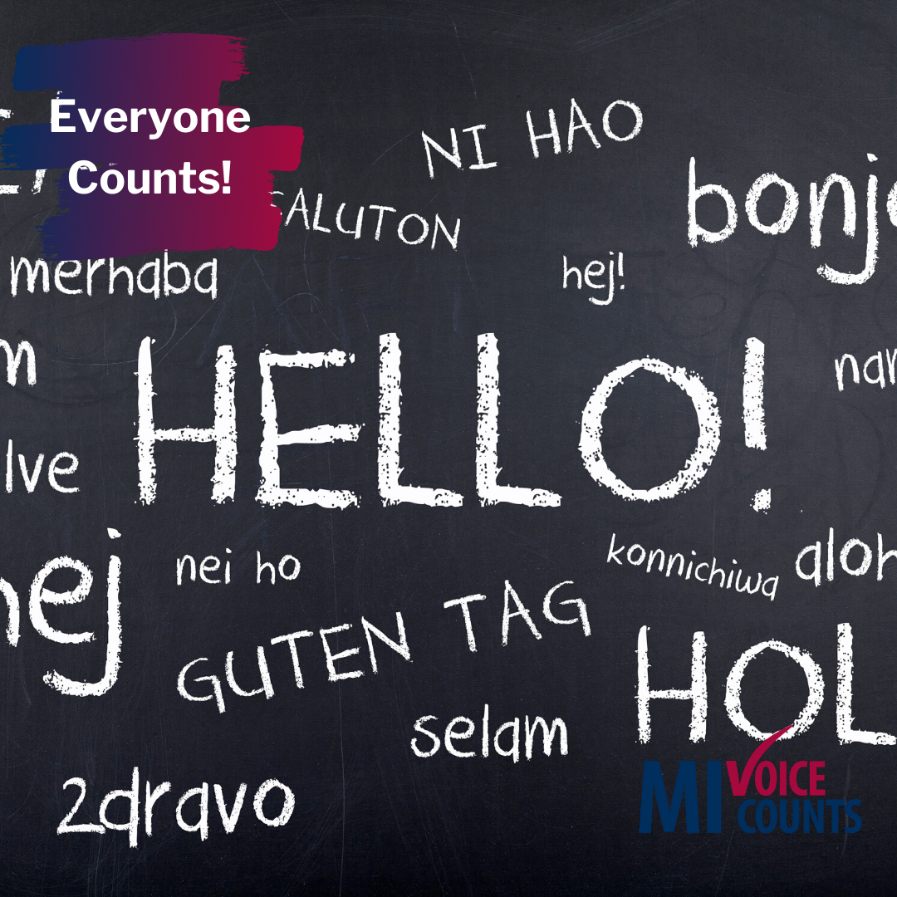 |  |  | Did you know that you can fill out the #census in English and 12 non-English languages? And, if one of those languages isn’t what you speak in your house, they have language guides (video and print) of 59 non- English languages.  .  To learn more about what to expect, visit MIVoiceCounts.org  #MIVoiceCounts #BeCountedMI2020 #2020Census #census2020 #languageexchange #privacy #confidential #misinformation | Did you know that you can fill out the #census in English and 12 non-English languages? And, if one of those languages isn’t what you speak in your house, they have language guides (video and print) of 59 non-English languages.  To learn more about what to expect, visit MIVoiceCounts.org
Week of March _____________  (Medical Programs) Everyone gets sick! |  |  | It’s been said that it’s better to have something and never need it, than to need something and never have it.  .  Everyone gets sick, and having access to medical programs can be a lifesaver.  .  Fill out the census Spring 2020 so you and your entire family can get proper medical care when you need it.  www.MIVoiceCounts.org  #MIVoiceCounts #BeCountedMI2020 #2020Census #census2020 #medicalcare #childrenshealth | It’s been said that it’s better to have something and never need it, than to need something and never have it.  .  Fill out the #census Spring 2020 so you and your family can get proper medical care when you need it.  www.MIVoiceCounts.org  #MIVoiceCounts #BeCountedMI2020 #2020Census #census2020 #medicalcare #childrenshealth
 | Week of March ______________  Things that take longer than filling out the census: Getting a haircut  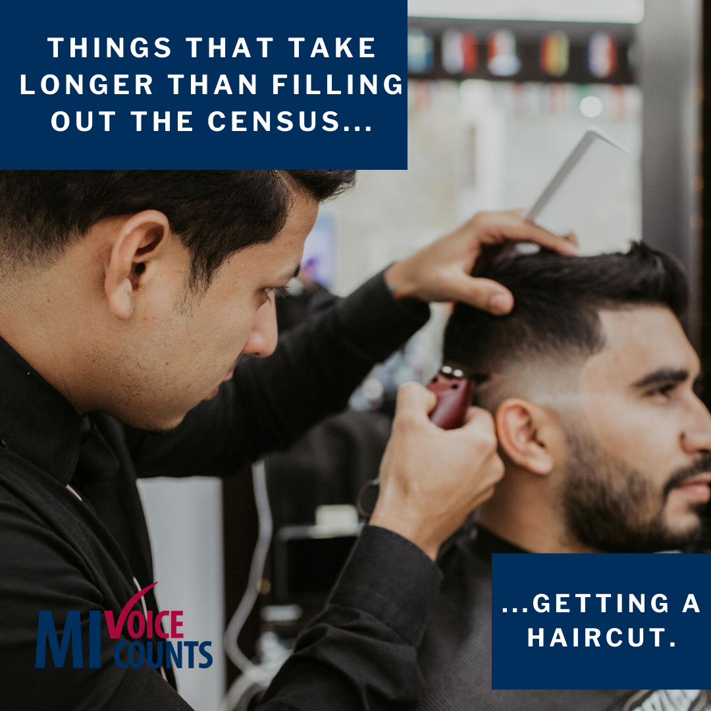 | Did you know you can fill out your census responses online? The process is quick and secure. You can respond to the census in less time than it takes to get a haircut. You’ll still be able to respond by mail.  .  Census forms are filled out by household. Everyone living at the address matters and everyone needs to be counted- including children.  To learn more about what to expect, visit MIVoiceCounts.org  #MIVoiceCounts #BeCountedMI2020 #2020Census #census2020 |  | The U.S. #Census Bureau will accept your responses online. The process is quick and secure. You can respond to the census in less time than it takes to fold a load of laundry.  To learn more about what to expect, visit MIVoiceCounts.org
 | Week of March ______________  (Census and children)  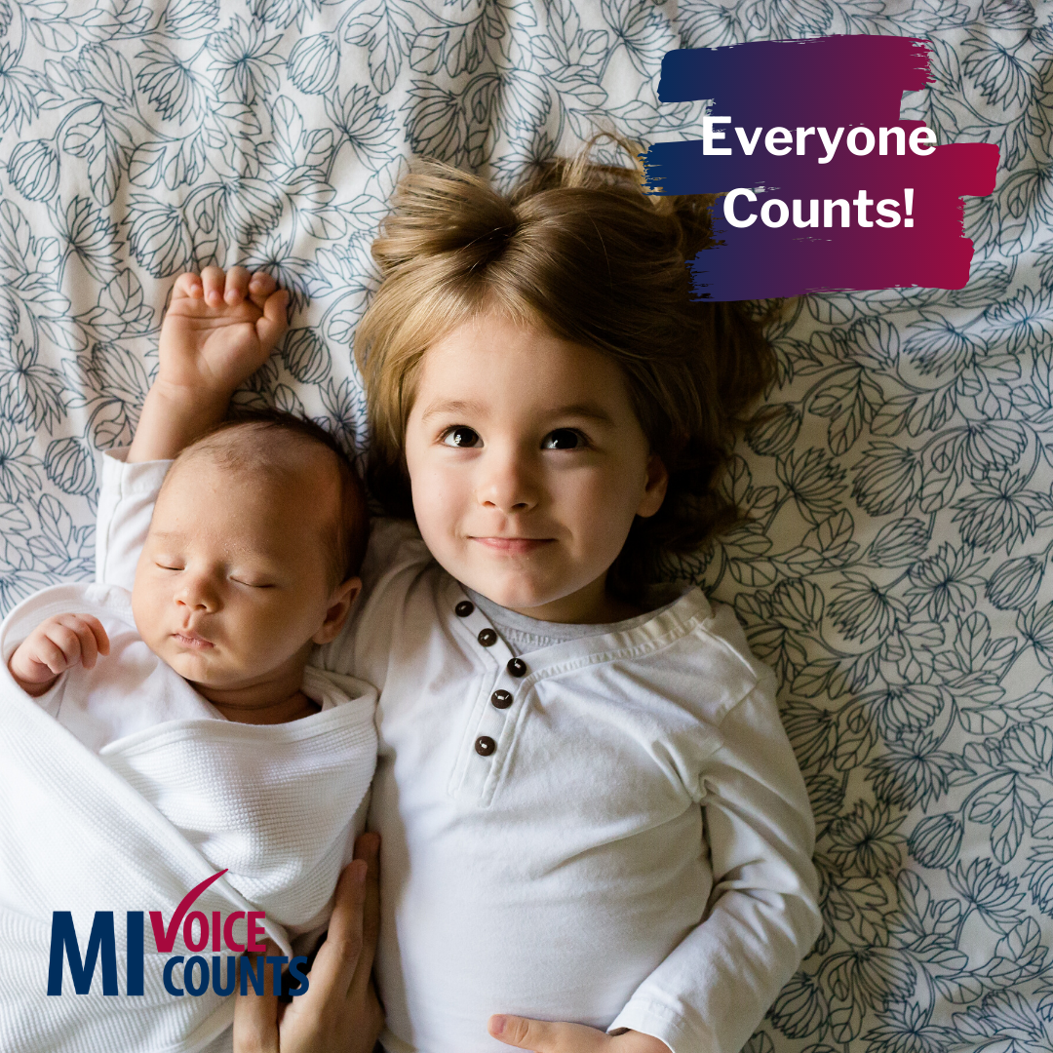 | Newborn babies and young children under five are often missed in the census.  .  When we don’t count young children, we lose 10 years of funding for school lunches, medical care, and college grants.  .  Census forms are filled out by household. Everyone living at the address matters and everyone needs to be counted- including children.  .  Your voice counts Spring 2020.  Checkout the 9 census questions here: www.MIVoiceCounts.org  #MIVoiceCounts #BeCountedMI2020 #2020Census #census2020 #childrenmatter #newborns #educationmatters |  | Newborn babies and young children under five are often missed in the census.  When we don’t count young children, we lose 10 years of funding for school lunches, medical care and college grants.  Your voice counts Spring 2020.  #MIVoiceCounts #BeCountedMI2020 #2020Census #census2020 #childrenmatter #newborns

