January 2020 Social Media Content Calendar: Motivate/Encourage Participation
To add pictures to social media, right click on the image and select “save picture as” to save image on your computer. Doing this restores correct sizing when uploading to social media.
Image |  |  | Facebook/Instagram | Twitter
Week of January ____________  (2020 Resolutions)  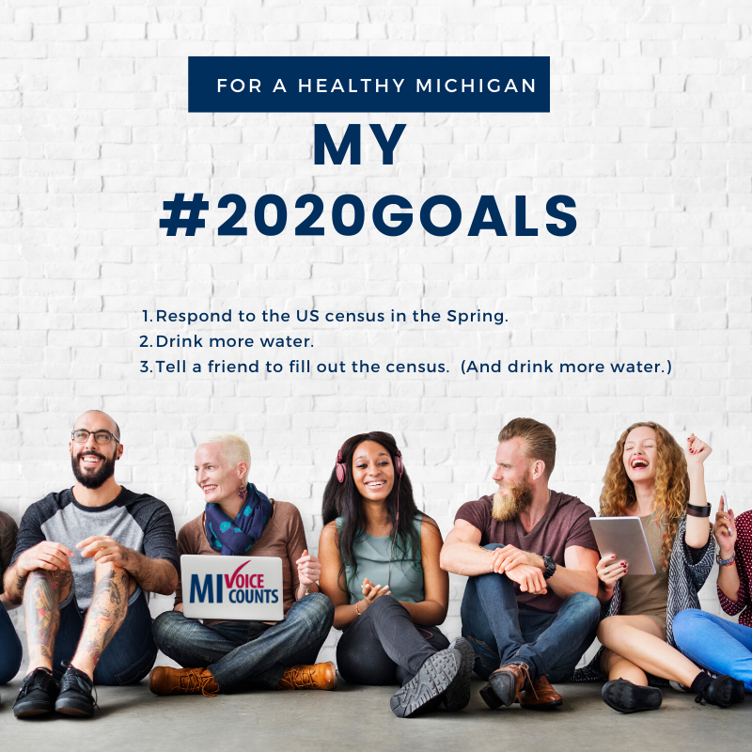 |  |  | Still making resolutions for the new year? Here are a few for your list:  - Respond to the US census in the Spring.  - Drink more water.  - Tell a friend to fill out the census. (And drink more water.)  Make your voice heard Spring 2020. Fill out the census. Everyone Counts. Everyone Wins.  www.MIVoiceCounts.org  #MIVoiceCounts #BeCountedMI2020 #2020Census #census2020 | Still making resolutions for the new year? Here are a few for your list:  - Respond to the US census in the Spring.  - Drink more water.  - Tell a friend to fill out the census. (And drink more water.)  Make your voice heard Spring 2020. Fill out the census.  #MIVoiceCounts #BeCountedMI2020 #2020Census #census2020
Week of January ______________  (Census data and roads)  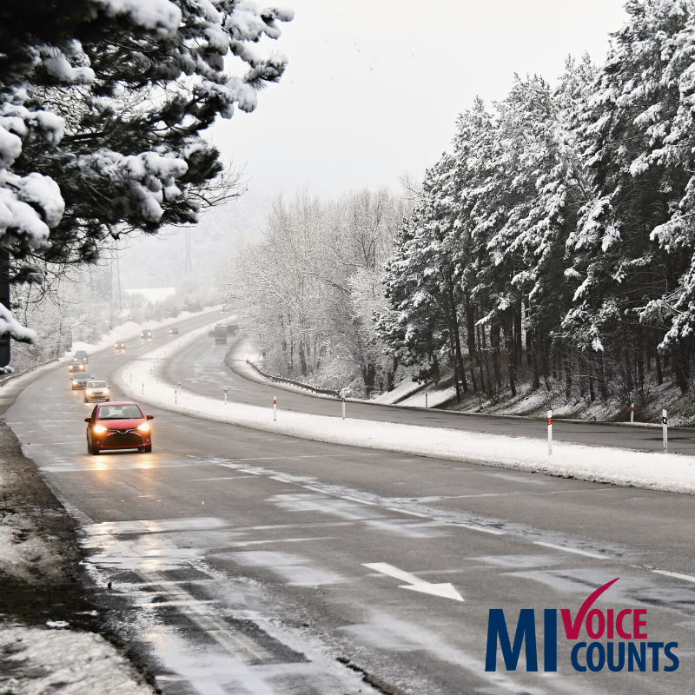 |  |  | Winter is here, and that means our roads take a beating. Filling out the census ensures our community receives funding to maintain our streets, highways, and bridges. Fill out the census Spring 2020. Your car thanks you!  When Everyone Counts. Everyone Wins! Be counted: www.MIVoiceCounts.org #MIVoiceCounts #BeCountedMI2020 #2020Census #census2020  #michiganroads | Winter is here, and our roads take a beating. Filling out the census ensures our community receives funding to maintain our streets, highways, and bridges. Fill out the census Spring 2020. Your car thanks you!  www.MIVoiceCounts.org. #MIVoiceCounts #BeCountedMI2020 #2020Census #census2020  #michiganroads
Week of January ______________  (Census and children) |  |  | It’s quiz time! Who should you NOT count in your household on the census?  - Yourself  - Your cute 1 month old baby  - Your dog  If you guessed “c” you’re pretty much a census expert. Congrats!  Your voice counts Spring 2020.  When Everyone Counts. Everyone Wins! Be counted: www.MIVoiceCounts.org  #MIVoiceCounts #BeCountedMI2020 #2020Census #census2020 #childrenmatter #newborns | It’s quiz time! Who should you NOT count in your household on the census?  - Yourself  - Your cute 1 month old baby  - Your dog  If you guessed “c” you’re pretty much a census expert. Congrats!  Your voice counts Spring 2020.  #MIVoiceCounts #BeCountedMI2020 #2020Census #census2020 #childrenmatter #newborns
Week of January ______________  (Confidentiality) |  |  | The census is confidential.  The census will NOT ask for your:  - Social Security Info  - Banking Information  - Citizenship Status  - Income  - Voting Records  It’s the law that your census information cannot and will not be shared with ANY agency. Check out the nine census questions here: www.MIVoiceCounts.org  #MIVoiceCounts #BeCountedMI2020 #2020Census #census2020 #privacy | Not sure about filling out the #census? Worried about your personal information? It’s the law that your census information cannot and will not be shared with ANY agency. Check out the nine census questions here: www.MIVoiceCounts.org  #BeCountedMI2020 #MIVoiceCounts
Week of January ______________  (Census impact) 9-10-10  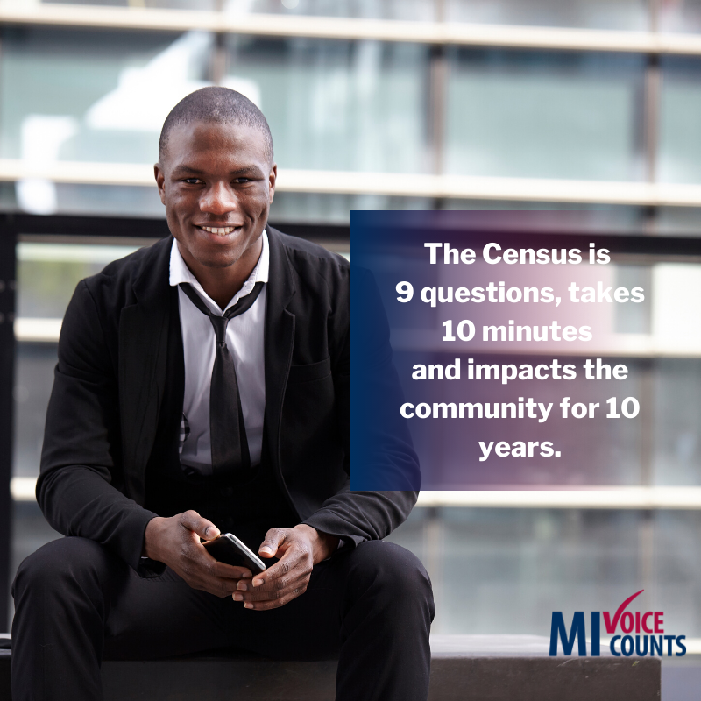 |  |  | The census is only 9 questions.  That’s right, 9 questions. It takes less than 10 minutes to complete and impacts our community for 10 years.  Everyone who fills out the census helps make a true difference in the lives of their neighbors, friends, and family. Census data affect things like public libraries, school lunch programs, and health services. Check out the 9 questions here: www.MIVoiceCounts.org  #MIVoiceCounts #BeCountedMI2020 #2020Census #census2020 #communityimpact #communitydevelopment | The census is only 9 questions.  That’s right, 9 questions. It takes less than 10 minutes to complete and impacts our community for 10 years.  Check out the 9 questions here: www.MIVoiceCounts.org  #MIVoiceCounts #BeCountedMI2020 #2020Census #census2020
Week of January _____________  (Medical Programs) Everyone gets sick!  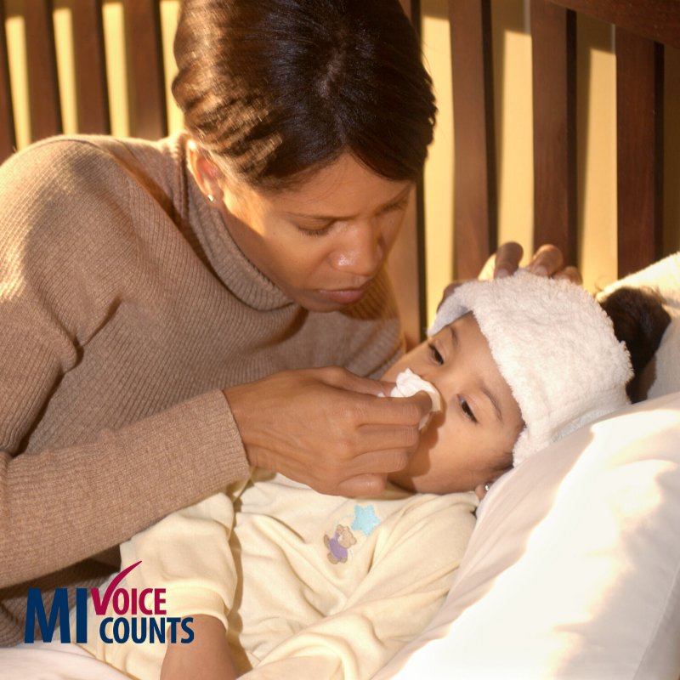 |  |  | Everyone gets sick. This year’s cold and flu season reminds us of the importance of tissues cough medicine, and access to medical care. Fill out the census Spring 2020 so you and your entire family can get proper medical care when you need it.  www.MIVoiceCounts.org  #MIVoiceCounts #BeCountedMI2020 #2020Census #census2020 #medicalcare #childrenshealth | Everyone gets sick. This year’s cold and flu season reminds us of the importance of tissues, cough medicine, and access to medical care. Fill out the census Spring 2020 so you and your entire family can get proper medical care when you need it.  #MIVoiceCounts #BeCountedMI2020 #2020Census #census2020 #medicalcare #childrenshealth
Week of January _____________  (What matters to you. Make your priorities count.)  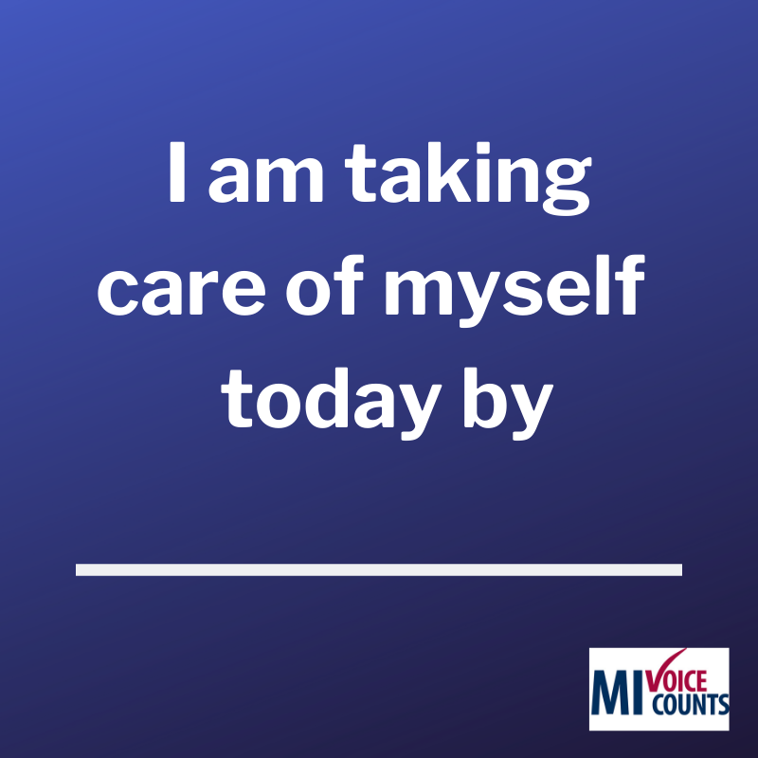 |  |  | What matters to you? Schools? Transportation? Medical programs? Small businesses?  Data from the census help inform planning efforts for all these essential community  resources. Make your priorites count.  To learn how filling out the census impacts what matters to you, visit  www.MIVoiceCounts.org  #MIVoiceCounts #BeCountedMI2020 #2020Census #census2020 #communitydevelopment #socialimpact #selfcare | What matters to you? Schools? Transportation? Medical programs? Small businesses?  To learn how filling out the census impacts what matters to you, visit  www.MIVoiceCounts.org  #MIVoiceCounts #BeCountedMI2020 #2020Census #census2020 #communitydevelopment #socialimpact

