February 2020 Social Media Content Calendar: Motivate/Encourage Participation
To add pictures to social media, right click on the image and select “save picture as” to save image on your computer. Doing this restores correct sizing when uploading to social media.
Image |  |  | Facebook/Instagram | Twitter
Week of February ____________  (Count Children)  Where will your kid be ten years from now?  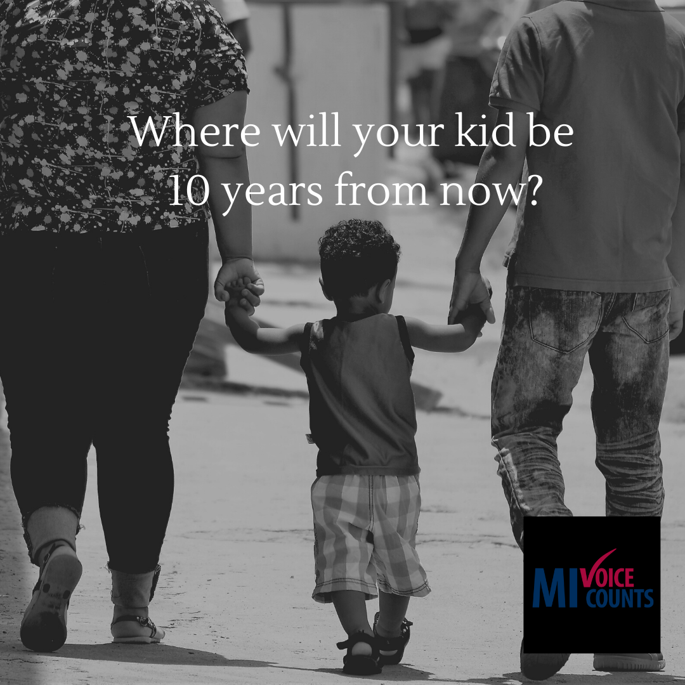 |  |  | As a parent, you want to give your child tools for a happy and healthy life. From their education to the food they eat, #census data impacts them daily. Head Start, college grants and school lunches are fully funded when every child in your home is counted.  Don’t just think about them today; think about them 10 years from now. Give them a voice in the Spring. Fill out the census.  www.MIVoiceCounts.org  #MIVoiceCounts #BeCountedMI2020 #2020Census #census2020 #childrenshealth #kidsmatter | Give your child tools for a happy and healthy life. Head Start, college grants, and school lunches are fully funded when every child in your home is counted in the #census.  Think about them today, and 10 years from now. Give them a voice. Fill out the census.  #MIVoiceCounts #BeCountedMI2020 #2020Census #census2020
Week of February Valentine’s Day  (Census impact)  Show your community some love. Fill out the census!  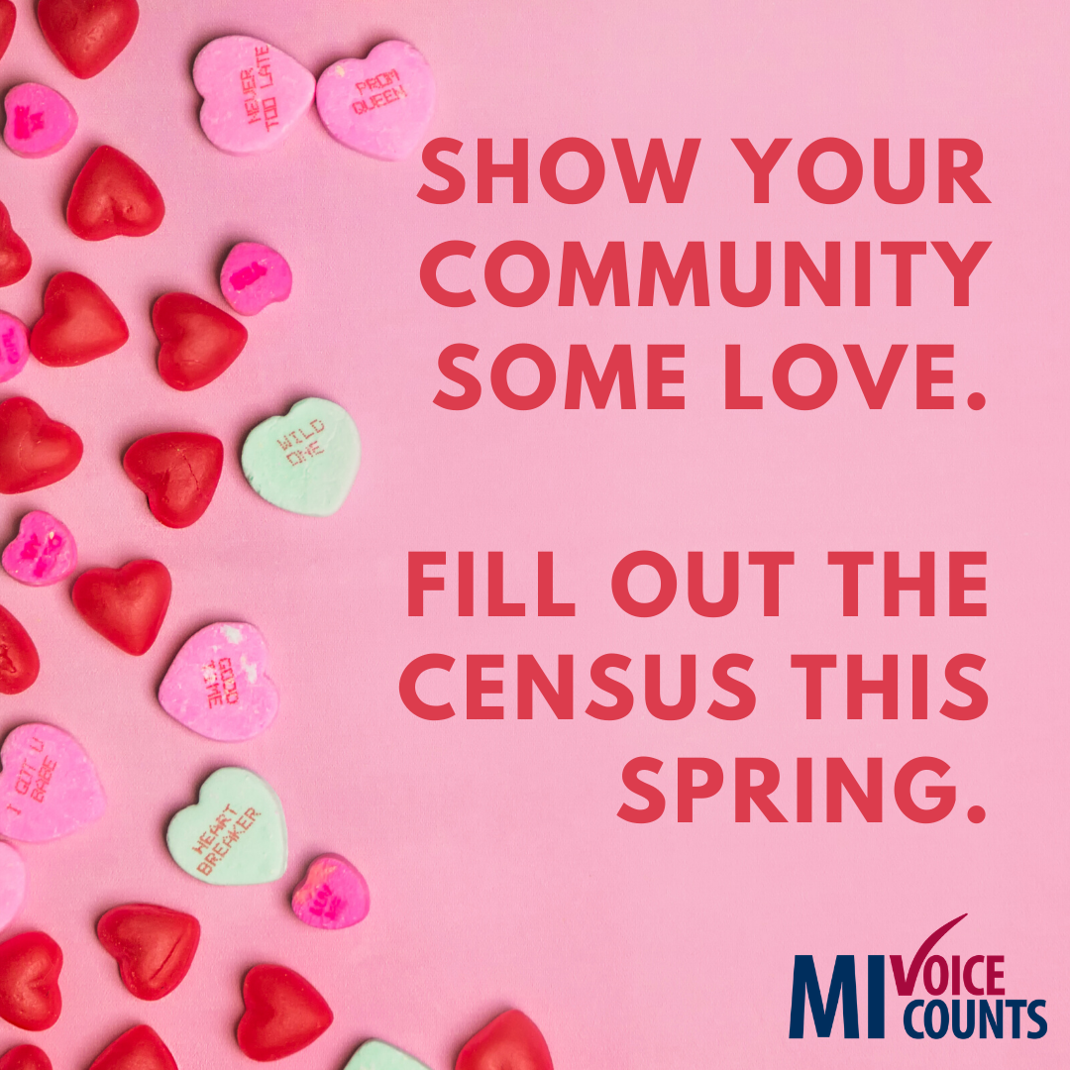 |  |  | The #census is only 9 questions.  That’s right, 9 questions. It takes less than 10 minutes to complete and impacts our community for 10 years.  Everyone who fills out the census helps make a true difference in the lives of their neighbors, friends, and family. Census data affect things like public libraries, school lunch programs, and health services. Show your community some love and fill out the census. Check out the 9 questions here: www.MIVoiceCounts.org  #MIVoiceCounts #BeCountedMI2020 #2020Census #census2020 #communityimpact #communitydevelopment #showyourlove #spreadkindness | The census is only 9 questions.  That’s right, 9 questions. It takes less than 10 minutes to complete and impacts our community for 10 years.  Check out the 9 questions here: www.MIVoiceCounts.org  #MIVoiceCounts #BeCountedMI2020 #2020Census #census2020
Week of January ______________  (Census and children)  Count the babies!  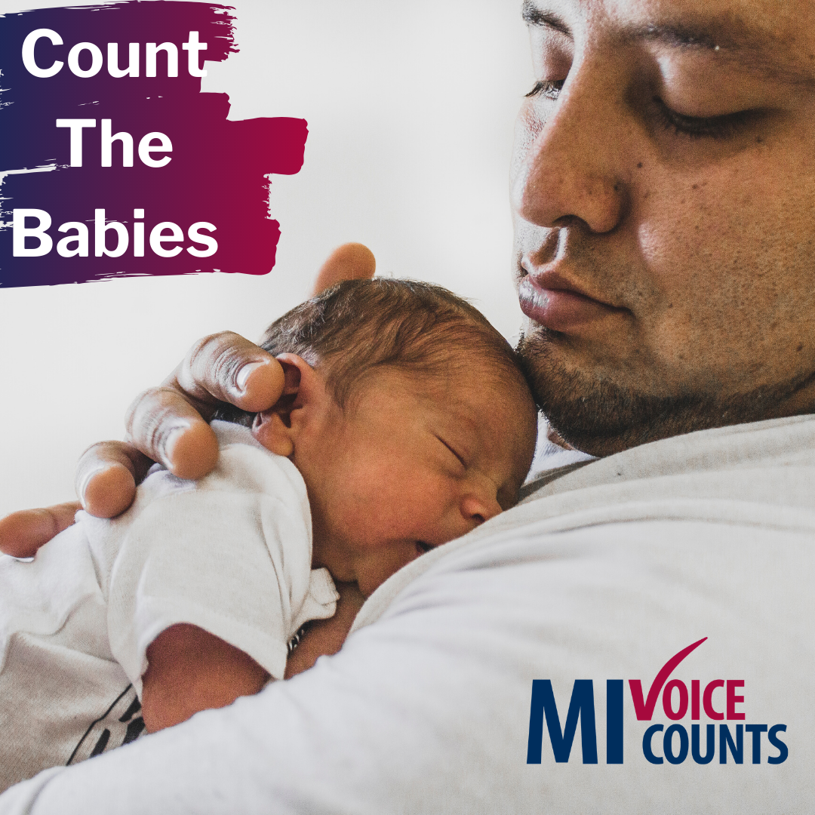 |  |  | Newborn babies and young children under five are often missed in the census. Count your kids, so they get the resources your family depend on for the next 10 years — basically, an entire childhood! When Everyone Counts. Everyone Wins! Checkout the 9 census questions here: www.MIVoiceCounts.org  #MIVoiceCounts #BeCountedMI2020 #2020Census #census2020 #childrenmatter #kidsmatter #newborns | Your voice counts Spring 2020.  #MIVoiceCounts #BeCountedMI2020 #2020Census #census2020 #childrenmatter #newborns
Week of February ______________  (Confidentiality)  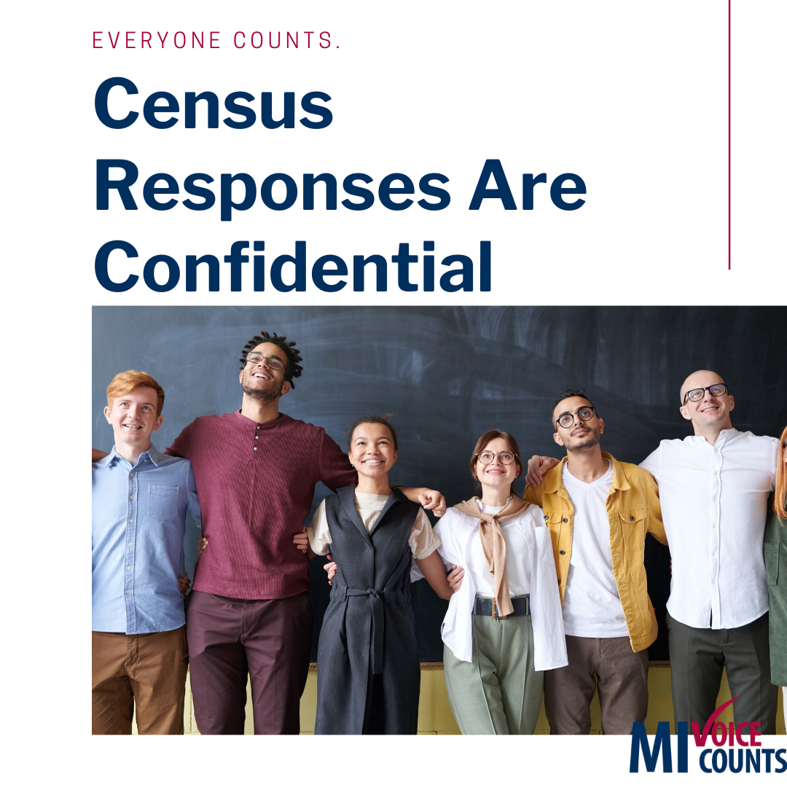 |  |  | The census is confidential. Your answers will NOT be shared with:  - CIA  - FBI  - DHS  - ICE  It’s the law that your census information cannot and will not be shared with ANY agency. Check out the nine census questions here: www.MIVoiceCounts.org  #MIVoiceCounts #BeCountedMI2020 #2020Census #census2020 #privacy #confidential | The #census is confidential. It’s the law that your answers will NOT be shared with:  - CIA  - FBI  - DHS  - ICE  Check out the nine census questions here: www.MIVoiceCounts.org  #BeCountedMI2020 #MIVoiceCounts #confidential #privacy
Week of February ______________  (Census data and roads)  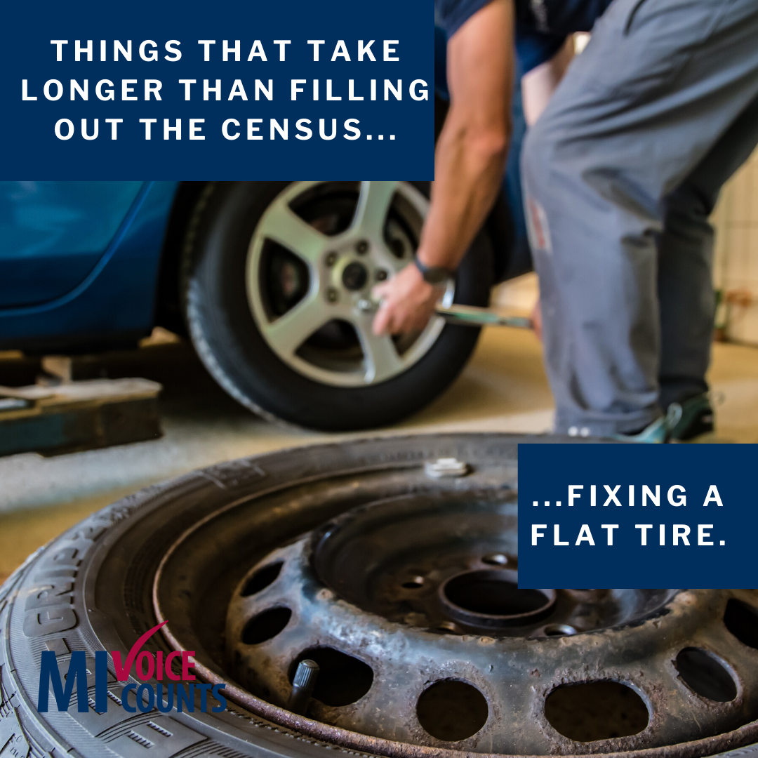 |  |  | It takes more time to fix a flat tire than it does to fill out the #census. And Michigan winters are known to keep our roads in need of repair. Fill out the census, so our community receives funding to maintain our streets, highways, and bridges. Fill out the census Spring 2020 and protect your vehicle from Michigan winters!  When Everyone Counts. Everyone Wins! Be counted: www.MIVoiceCounts.org #MIVoiceCounts #BeCountedMI2020 #2020Census #census2020  #michiganroads #tirerepair | It takes more time to fix a flat tire than it does to fill out the #census. Fill out the #census this Spring so our community receives funding to maintain our streets, highways, and bridges.  www.MIVoiceCounts.org. #MIVoiceCounts #BeCountedMI2020 #2020Census #census2020  #michiganroads #tirerepair
Week of February _____________  (Medical Programs) Everyone gets sick! |  |  | Everyone gets sick. This year’s cold and flu season reminds us of the importance of tissues, cough medicine, and access to medical care. Fill out the census Spring 2020 so you and your entire family can get proper medical care when you need it.  www.MIVoiceCounts.org  #MIVoiceCounts #BeCountedMI2020 #2020Census #census2020 #medicalcare #childrenshealth #fluseason #sickdays | Everyone gets sick. This year’s cold and flu season reminds us of the importance of tissues, cough medicine, and access to medical care. Fill out the census Spring 2020 so you and your entire family can get proper medical care when you need it.  #MIVoiceCounts #BeCountedMI2020 #2020Census #census2020 #medicalcare #childrenshealth
Week of February _____________  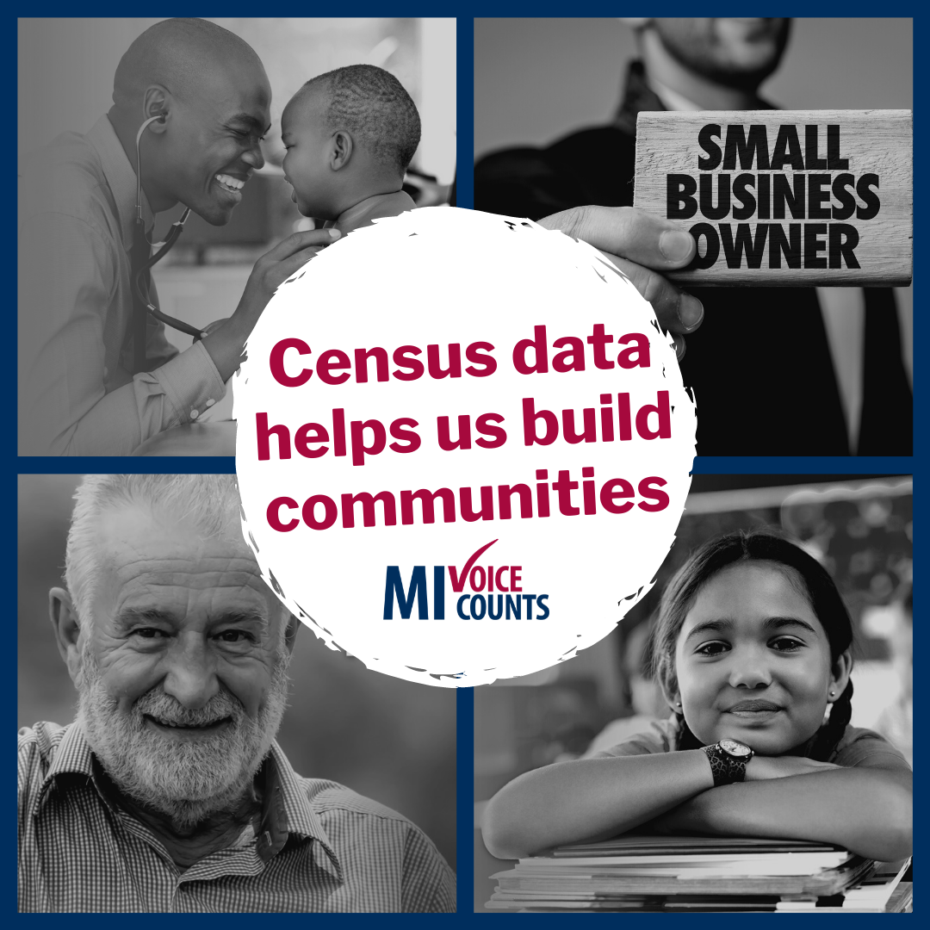 |  |  | What matters to you? Schools? Transportation? Medical programs? Small businesses?  Data from the census help inform planning efforts for all these essential community resources. Make your priorities count.  To learn how filling out the census impacts what matters to you, visit  www.MIVoiceCounts.org  #MIVoiceCounts #BeCountedMI2020 #2020Census #census2020 #communitydevelopment #socialimpact #selfcare | What matters to you? Schools? Transportation? Medical programs? Small businesses?  To learn how filling out the census impacts what matters to you, visit  www.MIVoiceCounts.org  #MIVoiceCounts #BeCountedMI2020 #2020Census #census2020 #communitydevelopment #socialimpact
 | Week of February ______________  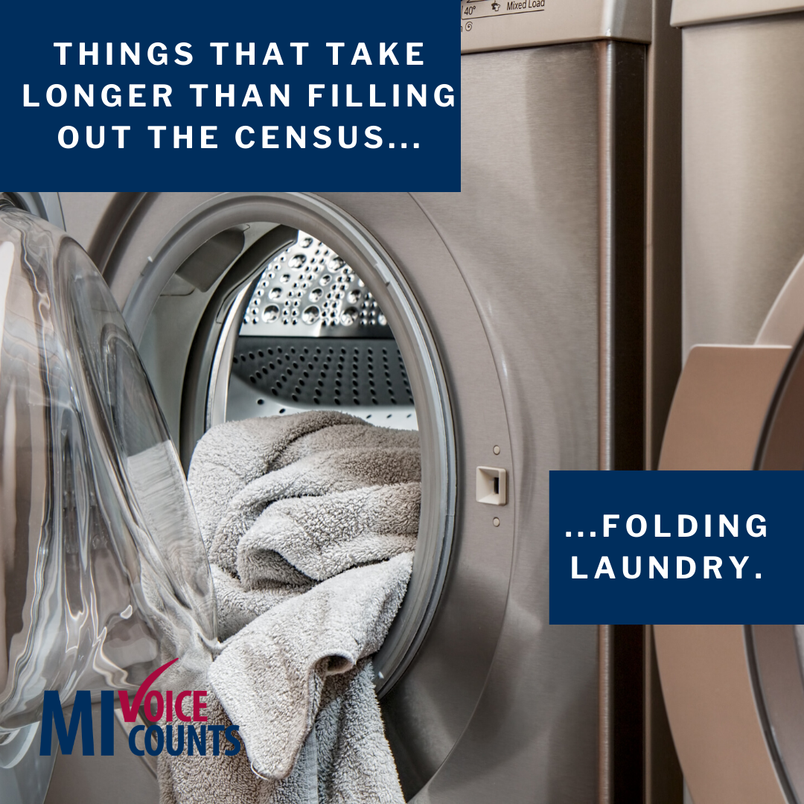 | The U.S. #Census Bureau will accept your responses online. The process is quick and secure. You can respond to the census in less time than it takes to fold a load of laundry. You’ll still be able to respond by mail. To learn more about what to expect, visit MIVoiceCounts.org  #MIVoiceCounts #BeCountedMI2020 #2020Census #census2020  #laundryhacks #laundryday #tidyhome |  | The U.S. #Census Bureau will accept your responses online. The process is quick and secure. You can respond to the census in less time than it takes to fold a load of laundry.  To learn more about what to expect, visit MIVoiceCounts.org
 | Week of February _____________________  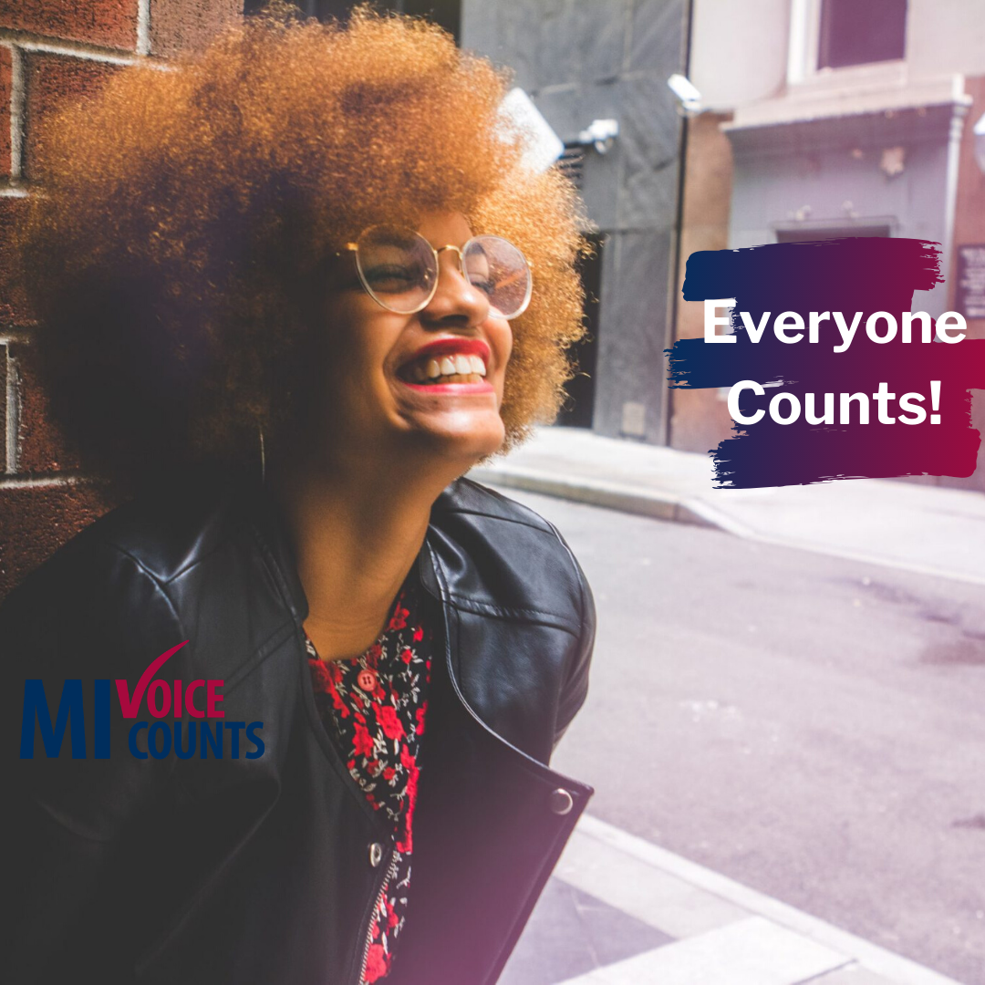 | Use your voice to make sure your community gets what it needs. Filling out the #census funds resources like libraries, Head Start, grants for college, medical care, and food programs. Make your voice heard this Spring.  #MIVoiceCounts #BeCountedMI2020 #2020Census #census2020 #communitydevelopment #socialimpact #youcount #imatter |  | Filling out the #census funds resources like libraries, Head Start, grants for college, medical care, and food programs. Make your voice heard this Spring.  #MIVoiceCounts #BeCountedMI2020 #2020Census #census2020 #communitydevelopment #socialimpact #youcount #imatter
 | Videos and articles to share
 | https://www.youtube.com/watch?v=MVLYq--JZEo&t=82s | Are you smarter than a 5th grader when it comes to the #census? Take the 2020 Census Challenge and find out!  #MIVoiceCounts #BeCountedMI2020 #2020Census #census2020 #trivianight
 | https://www.youtube.com/watch?v=Q_5OsnSJRy0 | Did you spend a little too much during the holidays? Need to make some extra money this year? Check out the Top 5: Census Recruiting and Jobs Questions.  #2020Census #2020CensusJobs #hiring2020census

